Week Ahead
January16-20th 2023
Ma Murray Community School

Monday | Tuesday | Wednesday | Thursday | Friday
16 | 17 | 18 | 19 | 20
23  Assembly @ 9 am | 24 | 25 | 26  90’s Day Spirit Day  House team points | 27  Pro-D Day  School closed
30 | 31  Library closed for inventory | Feb 1 | 2 | 3  Hang Out  3-5:30 p.m.  Grade 1-6

It’s been a great week with many fun activities – snowshoes, dancing, cooking, tea and bannock are some of the highlights. Of course, “Crazy Hair Day” was the most popular day. Thank you for all that participated.

Spirit of Healthy Kids Challenge – The “Spirit of Healthy Kids” continues until Monday, January 23rd. This is an excellent opportunity for us to encourage students to read, exercise, rest and eat healthy for the two-week period. Click on the blue link and if you have questions, please contact the school. The school with the highest participation rate in Northern BC receives a prize of $5000. Other schools will be entered for draws of $1000. We look forward to hearing how students and staff participated in this challenge.

Kindergarten Registration 2023-2024: Kindergarten registration is open for all children who will be five by December 31st, 2023. Please register at your earliest convenience. We need your child’s birth certificate and proof of address. Immunization records are also encouraged. Early registration is welcome so that we can start the staffing process as soon as possible.
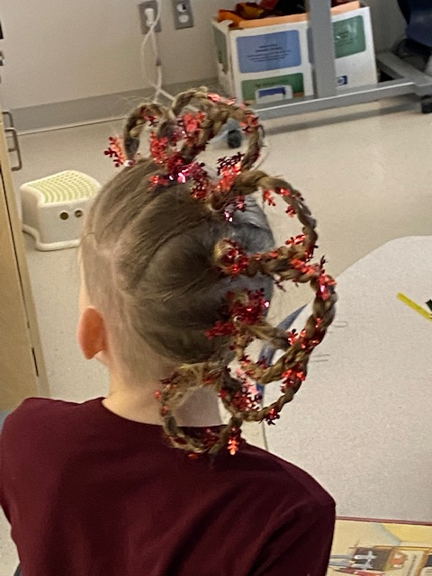
Crazy
Hair
Day
Miss Brittany makes the best bannock and tea!
Thank you

Tea and bannock for the win!

Parking Lot Issues: We continue to have issues in the parking lot, drive through lanes and on 105th Avenue drop off. We ask that vehicles not park in the bus lane, crosswalks, behind other vehicles in the staff parking lot or stop in the drive through lane. We are worried about student safety as we have had some close calls in the last few weeks. We know that it is hard to be patient but without your help, students and families will be hurt. Thank you for helping us keep safety at the forefront.

Basketball has started and the school has enough volunteers to run four teams. Students have been given their practice schedule. We have included the schedule below in case your child has lost theirs. What an excellent opportunity for our students to keep active. Thank you to all the volunteers for supporting this extra-curricular activity.

Team: | Practice Times:
Grade 4 Girls  (Miss Jaimelia) | Thursday 8:00-8:40 a.m.  Monday and Wednesday at lunch
Grade 4/5 Girls  (Mrs. Francoeur) | Tuesday 7:50-8:35 a.m.  Friday 7:50-8:35 a.m.
Grade 6 Girls  (Miss Polnik, Mrs. Ross, Mrs. Gray) | Wednesday 3:00-4:00 p.m.  Friday 8:00-8:40 a.m.
Grade 4 Boys  (Mrs. Pike, Mr. Marshall) | Monday 3:00-3:45 p.m.  Wednesday 3:00-3:45 p.m.
Grade 5 Boys  (Mr. Mackay, Mr. Chevalier) | Monday 2:50-3:50 p.m.  Wednesday 8:00-8:40 a.m.
Grade 6 Boys  (Mrs. Kraeleman, Miss Jesperson) | Tuesday 8:00 – 8:40 a.m.  Thursday 8:00-8:40 a.m.

Have a wonderful weekend everyone!

Mrs. Scheck Mr. Mackay Mrs. Gibos
Staff at Margaret “Ma” Murray Community School

As the days get longer and the weather co-operates, we will be spending more time outside. Please remind your students to dress appropriately for the weather.

Wishing you all a wonderful New Year.
Sincerely,

Mrs. Scheck Mr. Mackay Mrs. Gibos
Margaret Ma Murray Community School

