Vehicle

Book

200 points

Famous Person

200 points

Read for 15 minutes

200 points

Farm Animals

500 points

Directions:

Colour in each square that you complete the challenge for. Add up all your points and fill in the slip for the reading challenge below. Return the completed challenge by May 3rd.

Space or aliens

400 points

Your choice

100 points

Apples

200 points

Super HERO

200 points

Halloween Book

300 points

Science Content

300 points

Creepy Crawlies

200 points

Dr. Seuss

500 points

Indigenous

Content

300 points

Jungle Animal

400 points

Pets

300 points

Comic Book

300 points

Jokes or

Riddles

300 points

Drawing Book

300 points

A book of world records

500 points

Penguin book 500 points

Cook book for 500 points

Read an insect book

200 points

Read at home or 15 minutes

200 points

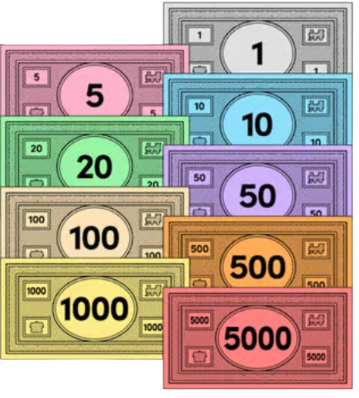

Graphic Novel

200 points

Read at home for 15 minutes

200 points

200 points

Read at home or 15 minutes

200 points

Collect 200 points for reading to a friend

Readopoly

April

Reading Challenge

Name: ________________. Teacher: _____________________

House Team Colour: ________ Points Collected: _______

Piggy and Gerald Book

100 points

A book about Canada 100 points

A book about trees

100 points

A Book About Bears

100 points